NORTHWIND TRADERS

Interactive Sales Dashboard
Business Insight Report

Prepared by: [VAISHNAVI K]
Roll / Registration No.: [5272510220]
Course / Subject: [POWER BI]
Date: 22 September 2026

Tool used: Microsoft Power BI Desktop

1. Introduction
This report presents a business analysis of the Northwind Traders dataset using an interactive Power BI dashboard. The dashboard consolidates order, product, employee, and customer data into a single interface so that sales performance can be explored dynamically rather than read off a static spreadsheet.

Northwind Traders Dataset
The dataset represents Northwind Traders, a specialty foods wholesaler, and covers 809 orders placed by 91 customers across 21 countries. It records products grouped into 8 categories (Beverages, Condiments, Confections, Dairy Products, Grains & Cereals, Meat & Poultry, Produce and Seafood), the employees who processed each order, order dates, quantities sold, freight charges, and customer locations. In total the dataset reflects roughly 51,300 units sold and about 1.27 million in sales value.

Purpose of the Dashboard
The dashboard was built to let a manager or analyst monitor total orders, quantity sold, freight cost, sales value, and customer coverage at a glance through KPI cards, and to drill into performance by product category, order month, employee, and customer country using the Year, Region and Category slicers.

Purpose of the Business Insight Report
This report interprets what the dashboard shows — translating the chart-level observations (highest/lowest categories, order trends, employee performance) into business insights and actionable recommendations for Northwind Traders' management.

2. Dashboard Overview
The Power BI file contains four report pages. Their exact names and the visuals placed on each, as verified directly from the report definition, are listed below.

Page | Purpose | Key Visuals
Sales Overview | Landing page with headline KPIs and top-level charts | 6 KPI cards (incl. Total Sales), Orders-by-Month line chart, Orders-by-Employee bar chart, Sales-by-Category column chart
Interactive Sales Dashboard | Main interactive page with slicers | Title banner, 5 KPI cards, Category / Region / Year slicers, Orders-by-Month line chart, Sales-by-Category column chart, Orders-by-Employee bar chart, back button
Product & Customer Analysis | Product- and geography-level detail | Product detail table (27+ products by category), Number-of-Customers-by-Country bar chart
Tool tip | Hover tooltip page (not a navigable page) | Total Sales, Total Orders and Total Quantity Sold mini-cards shown on hover over the category chart

Screenshot of the main interactive dashboard, unfiltered (Year, Region and Category all set to "All"):
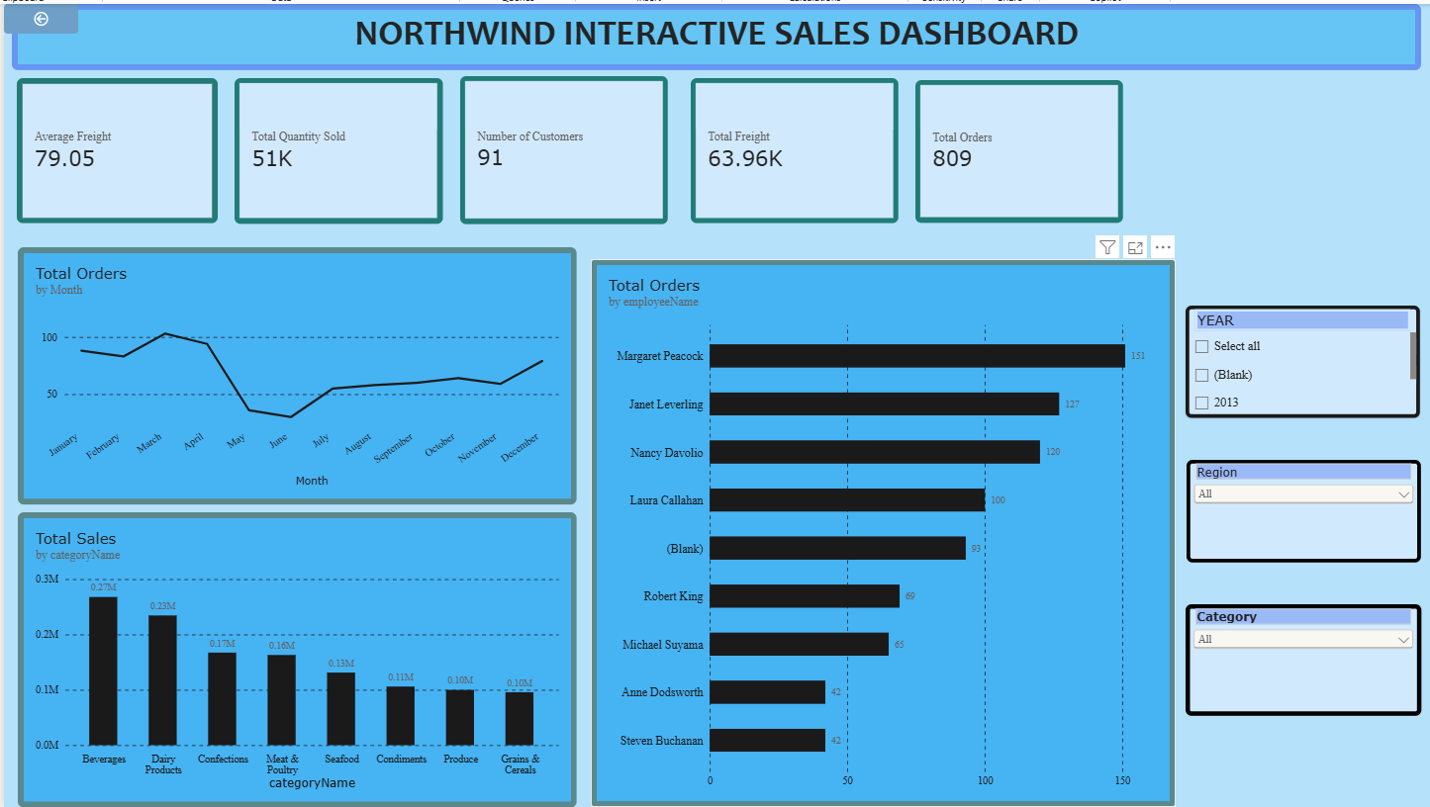
Fig. 1 — Interactive Sales Dashboard (full page, unfiltered)

Key Components
- KPI cards — Total Orders, Total Quantity Sold, Total Freight, Average Freight, Number of Customers
- Orders by Month — line chart (Total Orders by order date, month level)
- Sales by Product Category — clustered column chart (Total Sales by category)
- Orders by Employee — clustered bar chart (Total Orders by employee name)
- Category Tooltip — hover card showing Total Sales, Total Orders and Total Quantity Sold for a category

Interactive Filters Available
The following slicers are available on the Interactive Sales Dashboard page:
- Year — filters by order date year (Date Hierarchy); only 2013 and (Blank) appear in the data
- Region — filters by customer country (labelled "Region" on the dashboard)
- Category — filters by product category name

Supporting pages: the Tool tip page (Total Sales, Total Orders, Total Quantity Sold) and the Product & Customer Analysis page (product-level table and customer distribution by country) shown below.
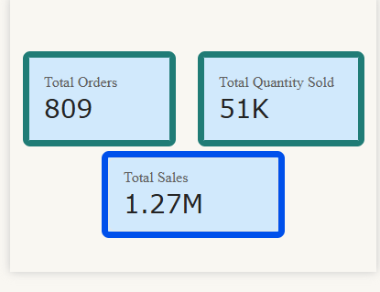
Fig. 2 — Category tooltip mini-cards

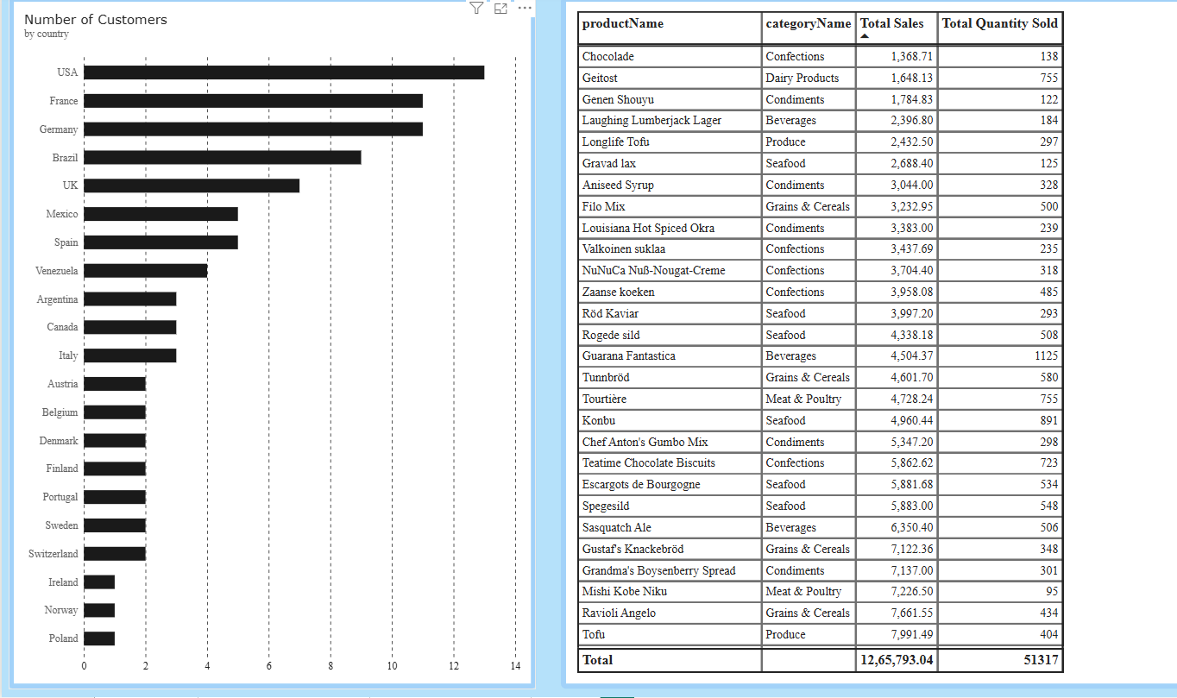
Fig. 3 — Product & Customer Analysis page: product detail table and Number of Customers by Country

3. KPI Analysis
Reading the KPI cards on the Interactive Sales Dashboard page (unfiltered view):

Total Orders
809 orders were placed in total. This is a moderate order volume for a wholesale distributor and, combined with only 91 customers, implies each customer places close to 9 orders on average — a healthy sign of repeat business rather than one-off purchases.

Total Quantity Sold
51K (51,317) units were sold across all orders, which puts the average order size at roughly 63 units — consistent with bulk/wholesale purchasing rather than small retail baskets.

Total Freight
Total freight cost across all orders is 63.96K. Relative to total sales of 1.27M, freight represents roughly 5% of sales value, which is a reasonable logistics cost ratio but still worth monitoring as order volume grows.

Average Freight
Average freight per order is 79.05. Since this is close to the freight-to-sales ratio implied above, it suggests freight cost is fairly consistent across orders rather than being driven by a few very large or very distant shipments.

No. of Customers
The dataset covers 91 customers spread across 21 countries, giving Northwind a genuinely international customer base rather than dependence on one or two large domestic accounts, as confirmed by the Number of Customers by Country chart (USA, France and Germany lead, but 18 other countries also appear).

Suggested Format
KPI | Value | Interpretation
Total Orders | 809 | Steady order volume; ~9 orders per customer on average
Total Quantity Sold | 51K (51,317 units) | ~63 units per order — typical of wholesale/bulk buying
Total Freight | 63.96K | ~5% of total sales value; a reasonable logistics cost ratio
Average Freight | 79.05 | Fairly consistent shipping cost per order
No. of Customers | 91 (across 21 countries) | Broad, internationally diversified customer base


Fig. 4 — KPI cards (unfiltered)

4. Product Category Performance Analysis
Sales by Product Category (unfiltered):
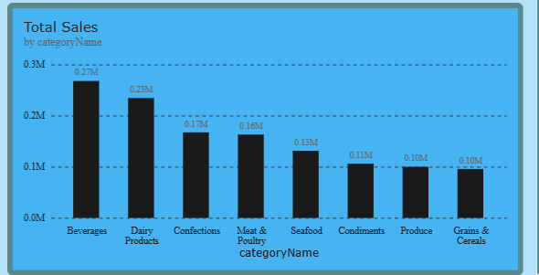
Fig. 5 — Total Sales by Category

Discuss:
- Highest-selling category — Beverages, at 0.27M, the single largest contributor to revenue
- Lowest-selling category — Grains & Cereals, at 0.10M (tied closely with Produce, also 0.10M)
- Relative differences — Beverages outsells the lowest category by roughly 2.7×, and the top two categories (Beverages and Dairy Products, 0.27M + 0.23M = 0.50M) together account for close to 40% of the 1.27M total sales
- Important observations — sales taper off fairly smoothly from Beverages down to Grains & Cereals rather than dropping off sharply after one category, meaning revenue is spread across a broad product range rather than concentrated in a single "hero" category

Key Insight
Beverages and Dairy Products are Northwind's clear revenue leaders and deserve priority in stock planning and promotion, while the four lowest categories (Seafood, Condiments, Produce, Grains & Cereals) collectively still contribute a meaningful ~0.44M and should not be neglected, but may warrant a review of pricing or marketing to close the gap with the top performers.

5. Monthly Order Trend Analysis
Orders by Month (unfiltered):
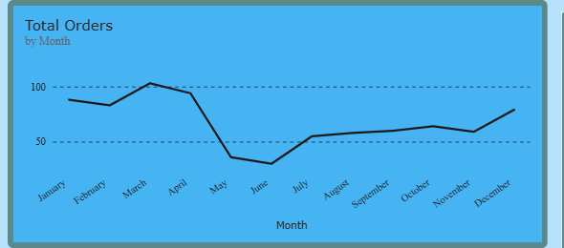
Fig. 6 — Total Orders by Month

Discuss:
- Highest-order month — March, at just over 100 orders, the peak of the year
- Lowest-order month — June, dipping to roughly 20 orders, the trough of the year
- Overall pattern — orders start strong (Jan–Apr, all near or above 85), fall sharply through May–June, then recover gradually and steadily climb back up from July through December
- Major fluctuations — the steepest change is the drop from April (~90) to June (~20), a fall of over 75%, followed by a slower, sustained recovery of roughly six months to approach earlier levels again by December

Key Insight
There is a pronounced early-summer slump (May–June) sandwiched between a strong Q1 and a gradually recovering H2. This is a strong seasonal signal that Northwind should plan inventory, staffing and promotions around — building up stock ahead of the Q1 peak and running targeted promotions in May–June to smooth out the trough.

6. Regional / Filter-Based Analysis
Since the dashboard uses a Region slicer rather than a separate regional chart, this section should show how the dashboard changes when different regions (countries) are selected.
Note: the screenshots supplied so far show the dashboard unfiltered plus the Number of Customers by Country chart (below), which identifies the top customer markets, but do not yet show the dashboard with the Region slicer actually applied. To complete the table below with real KPI/category/employee changes, take one more screenshot per region: select USA in the Region slicer and capture the resulting KPI cards and charts, then repeat for France and Germany.

Number of Customers by Country (unfiltered) — this identifies the top three customer markets used below:
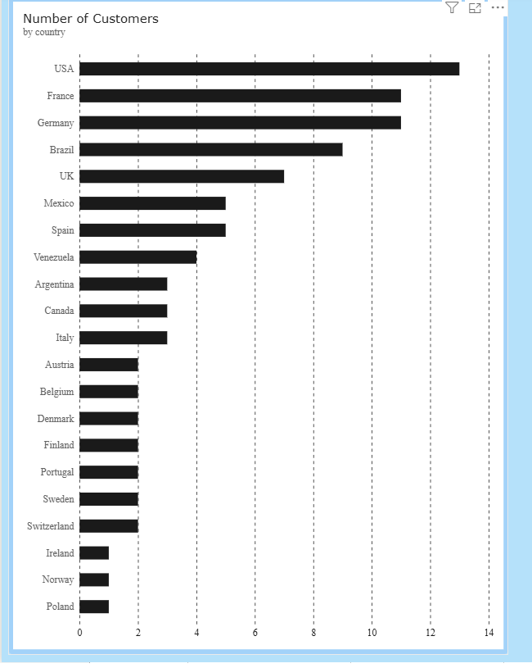
Fig. 7 — Number of Customers by Country

Discuss:
- KPI changes — [fill in after selecting each region in the slicer]
- Category changes — [fill in after selecting each region in the slicer]
- Monthly order changes — [fill in after selecting each region in the slicer]
- Employee performance changes — [fill in after selecting each region in the slicer]

Suggested Format
Region | Major Observation | Business Insight
USA (13 customers) | Largest single customer base in the dataset | [Select Region = USA on the slicer and fill in the resulting KPI/category shift]
France (11 customers) | Second-largest market, tied closely with Germany | [Select Region = France on the slicer and fill in the resulting KPI/category shift]
Germany (11 customers) | Tied with France for second place | [Select Region = Germany on the slicer and fill in the resulting KPI/category shift]

7. Employee Performance Analysis
Orders by Employee (unfiltered):
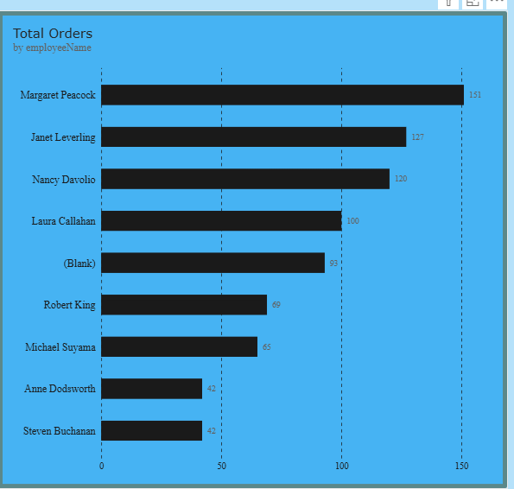
Fig. 8 — Total Orders by Employee

Discuss:
- Highest-performing employee — Margaret Peacock, with 151 orders, clearly ahead of the rest
- Lowest-performing employee — Anne Dodsworth and Steven Buchanan, tied at 42 orders each (excluding the 93 unattributed "(Blank)" orders, which likely indicate missing employee data rather than a real employee)
- Difference between employees — Margaret Peacock handles roughly 3.6× as many orders as the lowest performers; the top three (Margaret Peacock, Janet Leverling, Nancy Davolio — 151, 127, 120) together account for about 49% of all attributed orders
- Changes after applying filters — [apply the Region/Category/Year slicers and note whether the employee ranking stays the same or shifts]

Key Insight
Order-handling is concentrated among a small group of top performers (Margaret Peacock, Janet Leverling, Nancy Davolio), while Anne Dodsworth and Steven Buchanan handle noticeably fewer orders. This gap is worth investigating — it may reflect tenure, territory assignment, or part-time status, and represents an opportunity either for mentoring/training or for rebalancing workload.

8. Business Insights

Insight 1 — Revenue is concentrated in two categories
Beverages and Dairy Products together generate about 0.50M of the 1.27M total sales (roughly 40%). Northwind's revenue health is disproportionately tied to these two categories, which is both a strength (clear best-sellers to build around) and a risk (limited diversification).

Insight 2 — Strong seasonality with a May–June slump
Orders peak in March (~100+) and fall to their lowest point in June (~20) before gradually recovering through year-end. This is a clear, repeatable seasonal pattern rather than random noise, and planning (inventory, staffing, promotions) should be built around it.

Insight 3 — Order-handling is concentrated among a few employees
Just three employees (Margaret Peacock, Janet Leverling, Nancy Davolio) handle about half of all attributed orders, while two employees (Anne Dodsworth, Steven Buchanan) handle noticeably fewer. This uneven distribution could indicate either efficient specialization or an imbalance worth addressing.

Remember — Observation = what the data shows. Insight = what the observation means for the business.

9. Business Recommendations
Students should provide at least five recommendations.
Recommendations may relate to:
- Product category planning
- Inventory planning
- Regional strategy
- Employee performance
- Monthly order planning
- Freight management
- Customer targeting

# | Recommendation | Linked to Insight
1 | Increase stock and shelf/catalogue priority for Beverages and Dairy Products ahead of the Q1 peak | Insight 1
2 | Run targeted promotions or bundle offers for lower-performing categories (Grains & Cereals, Produce, Condiments) to lift their share of sales | Insight 1
3 | Plan for the May–June order slump — schedule promotions, discounts or new product launches specifically for this window rather than treating it as a passive dip | Insight 2
4 | Pre-build inventory and staffing ahead of the March peak so the highest-demand month is not supply-constrained | Insight 2
5 | Review workload distribution among sales employees — consider mentoring lower-order employees (Anne Dodsworth, Steven Buchanan) or rebalancing territory/customer assignments | Insight 3

Additional recommendation once regional screenshots are added: prioritise account management and localized marketing for the top three customer markets (USA, France, Germany), which together represent over a third of the customer base.

10. Conclusion
Provide a brief summary of:
- Overall dashboard findings
- Most important business insight
- Key recommendation
- How Power BI helped in the analysis

Overall dashboard findings: The Northwind Interactive Sales Dashboard shows a business with 809 orders, 51K units sold, 1.27M in sales, and 91 customers across 21 countries, at an average freight cost of 79.05 per order. Performance is uneven across categories (Beverages and Dairy Products lead), across the year (a strong Q1 followed by a May–June slump and gradual recovery), and across employees (three staff handle roughly half of all orders).
Most important business insight: The clearest actionable pattern is the seasonal order slump in May–June sandwiched between strong Q1 and H2 performance — this is the single biggest lever for smoothing revenue across the year.
Key recommendation: Proactively plan promotions, staffing and inventory around the May–June trough and the March peak, rather than treating monthly order volume as unpredictable.
How Power BI helped in the analysis: The interactive KPI cards, charts and slicers made it possible to see category, time and employee performance at a glance and to drill into specific regions, years and categories without needing separate static reports — turning raw Northwind order data into decision-ready business insight.

